Gross Primary Productivity Exercise
Pre-Exercise
- Who are the primary producers in an aquatic ecosystem?
- How do the limiting factors vary between the surface and the bottom of a lake?
- What does Gross Primary Productivity (GPP) and Net Primary Productivity (NPP) measure?
- What is the difference between GPP and NPP?
Background
The productivity of an aquatic ecosystem is the rate at which sunlight is stored by plants in the form of organic molecules using the following equation:
6CO₂ + 6H₂O + energy _{sun} C₆ H₁₂ O₆ + 6O₂
Because of respiration, some of the organic molecules made by photosynthesis are used to supply energy according to this equation:
C₆ H₁₂ O₆ + 6O₂ 6CO₂ + 6H₂O + ATP
Net Primary Productivity can be calculated using the following equation:
NPP = GPP (Gross Primary Productivity) – RL (Respiration Loss)
A depth profile shows how the productivity of a lake varies with depth. Typically, productivity is plotted as a gross primary productivity expressed as milligrams of organic carbon (C₆ H₁₂ O₆) produced per cubic meter of water per day (mg C/m³/day).
Respiration Loss is also plotted as mg C/m³/day. The following is a typical depth profile:
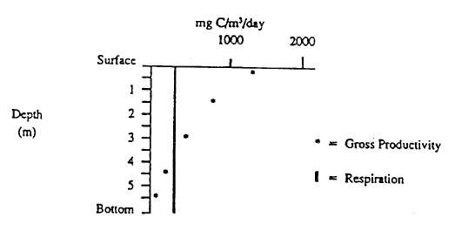
Exercise
In this exercise you will compare Tiger Paw Lake to Bulldog Pond. These two bodies of water are comparable in terms of overall size, depth, state of eutrophication, and species. The only major difference is turbidity, the amount of suspended particles in the water column.

The following two data charts show how the gross primary productivity, expressed as mL O₂/ liter / hour, varies with depth. In the space provided calculate gross primary productivity as milligrams (mg) carbon (C) / cubic meter / day using the following conversion units:
1 mL O₂ = 0.536 mg C and 1 m³ = 1000 liters
Please show your work on a separate sheet of paper.
DEPTH GPP GPP
(meters) mL O₂ / liters / hour mg C / m³ / day
Tiger Paw 0.0 0.15
0.5 0.15
1.5 0.13
2.5 0.10
4.0 0.06

Bulldog 0.0 0.16
1.5 0.15
4.0 0.14
7.0 0.10
11.0 0.07
After you have made the conversions, construct a depth profile for each lake, using the sample on the first page as a guide.
The respiration loss for both lakes is 0.09 ml O₂ / liter / hour = ________ mg C/m³/day.
This should also be plotted on your graphs. Draw a best fit line.
Analysis
1. Calculate the Net Primary Productivity in each lake at the depth of 1.5 meters:
2. Find the compensation point for each lake. This is the depth where Gross Primary Productivity equals Respiration Loss. At this depth, therefore, NPP will be zero.
3. Which lake has a greater turbidity? Explain your answer.
4. Which lake is more productive? Explain your answer.
5. Describe the effect of turbidity on productivity in a lake, citing support from your graph and calculations.

